NFT Inevitable course

Objective:

To gain a better understanding of NFT. What are NFTs, the ecosystem of NFTs, the applications of NFTs and the future of NFTs.

What are NFTs?

NFTs stand for Non-Fungible Tokens. Fungible items are those that can be interchanged between users or organizations, and all have the same value.

Non-Fungible Tokens (NFTs) are unique items which cannot be copied.

This is achieved using Blockchain. A blockchain is a growing list of records, called blocks. These blocks are linked together using cryptography. The blockchain is like an immutable and open record book. Everything can be audited anytime, by anyone, anywhere.

NFTs live on the blockchain. They are a way of granting ownership of a particular item to a particular person. All this is based on the blockchain, auditable by anyone independently from having the permission of any centralized organization, and therefore free from censorship.

Importance of NFT

Ownership -> The most important advantage of NFTs is proof of ownership. Since NFTs are on a blockchain network, they can help in associating ownership to a single account. Most important of all, NFTs are indivisible and could not be distributed among multiple owners. At the same time, the ownership advantages of NFTs ensure that buyers are safe from the concerns of fake NFTs.

Transferability -> It is easy to trade NFTs freely on particular markets with a wide range of options for trading. For example, NFTs could solve the problem of ‘walled gardens’ in the case of games.

Many games issue in-game items, and players purchase them to improve their gaming experience. However, the in-game items are restricted only to the environment of the games, and players could not use them anywhere else. Furthermore, players could lose their investment in the in-game collectibles or items when the game goes out of fashion.

In the case of NFTs, game developers could issue in-game items as NFTs, which players could hold in their digital wallets. Subsequently, players could use the in-game items outside the game or even sell them for a profit. Since NFTs are based on smart contracts, ownership transfers become easy by incorporating the use of smart contracts.

Authenticity -> NFTs are created on the blockchain, thereby implying the association of unique records with them. The unique traits of NFTs showcase their potential for contributing value. At the same time, NFT creators have the privilege of issuing only a specific number of NFTs to introduce scarcity of supply.

In the case of some NFTs, creators can opt for creating multiple replicas like in the case of tickets. On the other hand, the immutability of the blockchain on which NFTs are stored also provides the assurance of authenticity. Immutability in blockchain-based NFTs ensures that they are immune to modifications, removal, or replacement. Therefore, NFTs can easily showcase their authenticity as the most valuable quality.

Create Economic Opportunity -> In the present times, NFTs have found wide-ranging applications in the domain of digital content. The primary reason for the feasibility of NFTs in the world of digital content refers to the fragmented nature of the industry.

Content creators frequently encounter the concerns of other platforms gulping down their profits and potential for earning. The benefits of non-fungible tokens could lead to the development and growth of a completely new creator economy. The creator economy would focus on helping content creators avoid the need for transferring ownership to platforms used by them for publicizing their content.

With the help of NFTs, the ownership of content is integrated into the content only. So, when the creators sell their content, the funds directly go to them. If a new owner sells the NFT, the creator could receive royalties by setting up smart contracts while developing NFTs. The original creator can receive royalties for each re-sale of the token since the NFT metadata includes the creator’s address.

Important terms used in NFTs

Hash: A hash is a result of running a hashing function on some message. What this hashing function does is generate a sequence of letters and numbers that is based on the message you used as the input.

The key point here is that any single letter you change on the input message will result in a different hash.

Blockchain: A blockchain is essentially a digital ledger of transactions that is duplicated and distributed across the entire network of computer systems on the blockchain. Each block in the chain contains a number of transactions, and every time a new transaction occurs on the blockchain, a record of that transaction is added to every participant’s ledger. The decentralised database managed by multiple participants is known as Distributed Ledger Technology (DLT).

Blockchain is a type of DLT in which transactions are recorded with an immutable cryptographic signature called a hash.

Features of blockchain:

* They are decentralised
* They are fully public and auditable
* They are practically incorruptible

Cryptocurrencies: A digital currency in which transactions are verified and records maintained by a decentralized system using cryptography, rather than by a centralized authority.

Networks: Each network is a different blockchain and they are created for different purposes.

The Ethereum network’s purpose is to support technologies like NFTs, that's where they were implemented initially and that’s why most of them are priced on ETH. Later other networks were developed to support NFTs too, but faster and cheaper, like Polygon or Flow.

Layer: In the blockchain ecosystem, we can divide them into 2 layers:

**Layer 1**

Layer 1 refers to the blockchain itself. For example, Ethereum, Bitcoin, Solana, and Flow are all Layer 1 technologies.

**Layer 2**

Layer 2 refers to a network or technology that operates on top of an underlying blockchain in order to improve its scalability and efficiency.

Thus, by taking much of the data processing off the main blockchain, the network becomes less congested and more scalable.

Smart Contracts: Smart Contracts are programs stored on a blockchain that runs an auditable logic, that anyone can interact with and is unmodifiable (kind of, we’ll talk about it later). If certain conditions are met, that smart contract will carry out certain actions automatically, independent of any external agent.

NFT Ecosystem

Cryptocurrency Wallets:

MetaMask: One of the most famous wallets in the world, it works through a browser extension as well as a mobile app. MetaMask was specially created to interact with decentralized applications built on Ethereum's blockchain.

Marketplaces:

**OpenSea**

Founded in 2017, OpenSea is the world's largest marketplace for NFTs. Users can create and trade NFTs within the OpenSea platform, as well as import their own collection smart contracts. OpenSea keeps 2.5% of all transactions made within its platform.

**Coinbase NFT Marketplace:**

A marketplace to be launched in 2022 by Coinbase, one of the largest crypto exchanges in the world. It promises to be more social, with options like followers and following.

**Rarible:**

A very intuitive NFT marketplace that has its own token ($RARI) for users to help with platform governance.

**VeVe:**

Marketplace focused on mobile. It launches digital collectibles from famous brands such as Spider-Man, Jurassic Park, and Disney.

**Foundation:**

Ethereum-based marketplace focused on more premium arts.

Big Projects: Some collections and projects that develop their own marketplaces.

**NBA TopShot:**

A project launched by the NBA in partnership with Dapper Labs and which runs on the Flow blockchain. Here, users can collect NBA moments and exchange them with other users.

**Axie Infinity:**

A game that has appeared a lot in headlines where users collect creatures with different characteristics and battle with each other. It is based on the Ethereum blockchain and users can buy and sell items and creatures in the game's own marketplace.

**Sorare:**

Launched in 2018, Sorare is a fantasy game of football, where players buy, sell, trade, and manage a virtual team with digital player cards. The game is based on the Ethereum blockchain.

**CryptoPunks:**

One of the most famous NFT collections in the world, it consists of 10,000 cryptopunk avatars. It was launched in 2017 and is now a symbol of the crypto community. The Cryptopunks is one of the earliest examples of NFTs, and their technology inspired the development of tech standards that are used by almost all NFTs today.

**Virtual Worlds**

Since Facebook changed its name to Meta, Metaverse has been making more and more headlines. The fact is that some companies have been working on virtual worlds projects for a long time and, within the universe of NFTs and blockchain, two of the main projects have attracted millions of users, creators, brands, and a lot of money.

The Sandbox:   
The Sandbox is a virtual world where players can build and play virtual experiences,  at the same time that they own and monetize their creations through NFTs, creating digital assets and other experiences. The company sells lands from this world to creators and brands.

Below, part of the Sandbox Game map. Notice how some brands like Atari and MetaMask own some land.

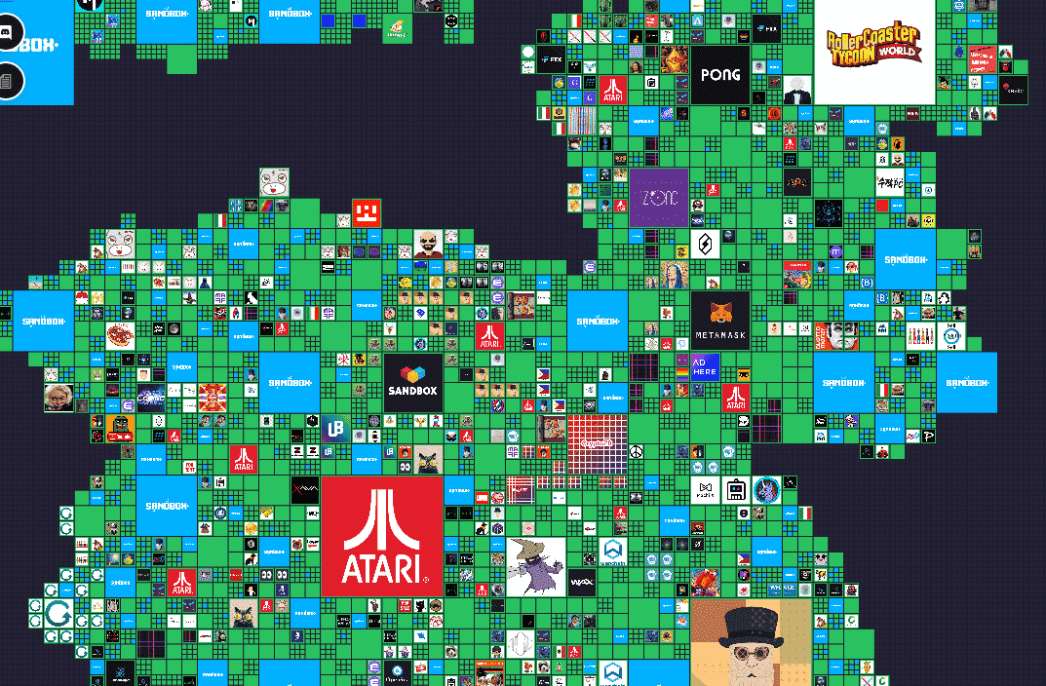

Decentraland:

Decentraland is a virtual world where users create experiences and events and can buy and sell NFTs that represent lands and digital items.

Minting the NFT Certificate:

Steps:

* Create a MetaMask Wallet
* Connect WalletGraphical user interface, application, Teams

  Description automatically generated
* Confirm the connection

* **Set the name for your certificate**

* **Mint**

* **Sign the transaction**

* **Click to see your certificate**

